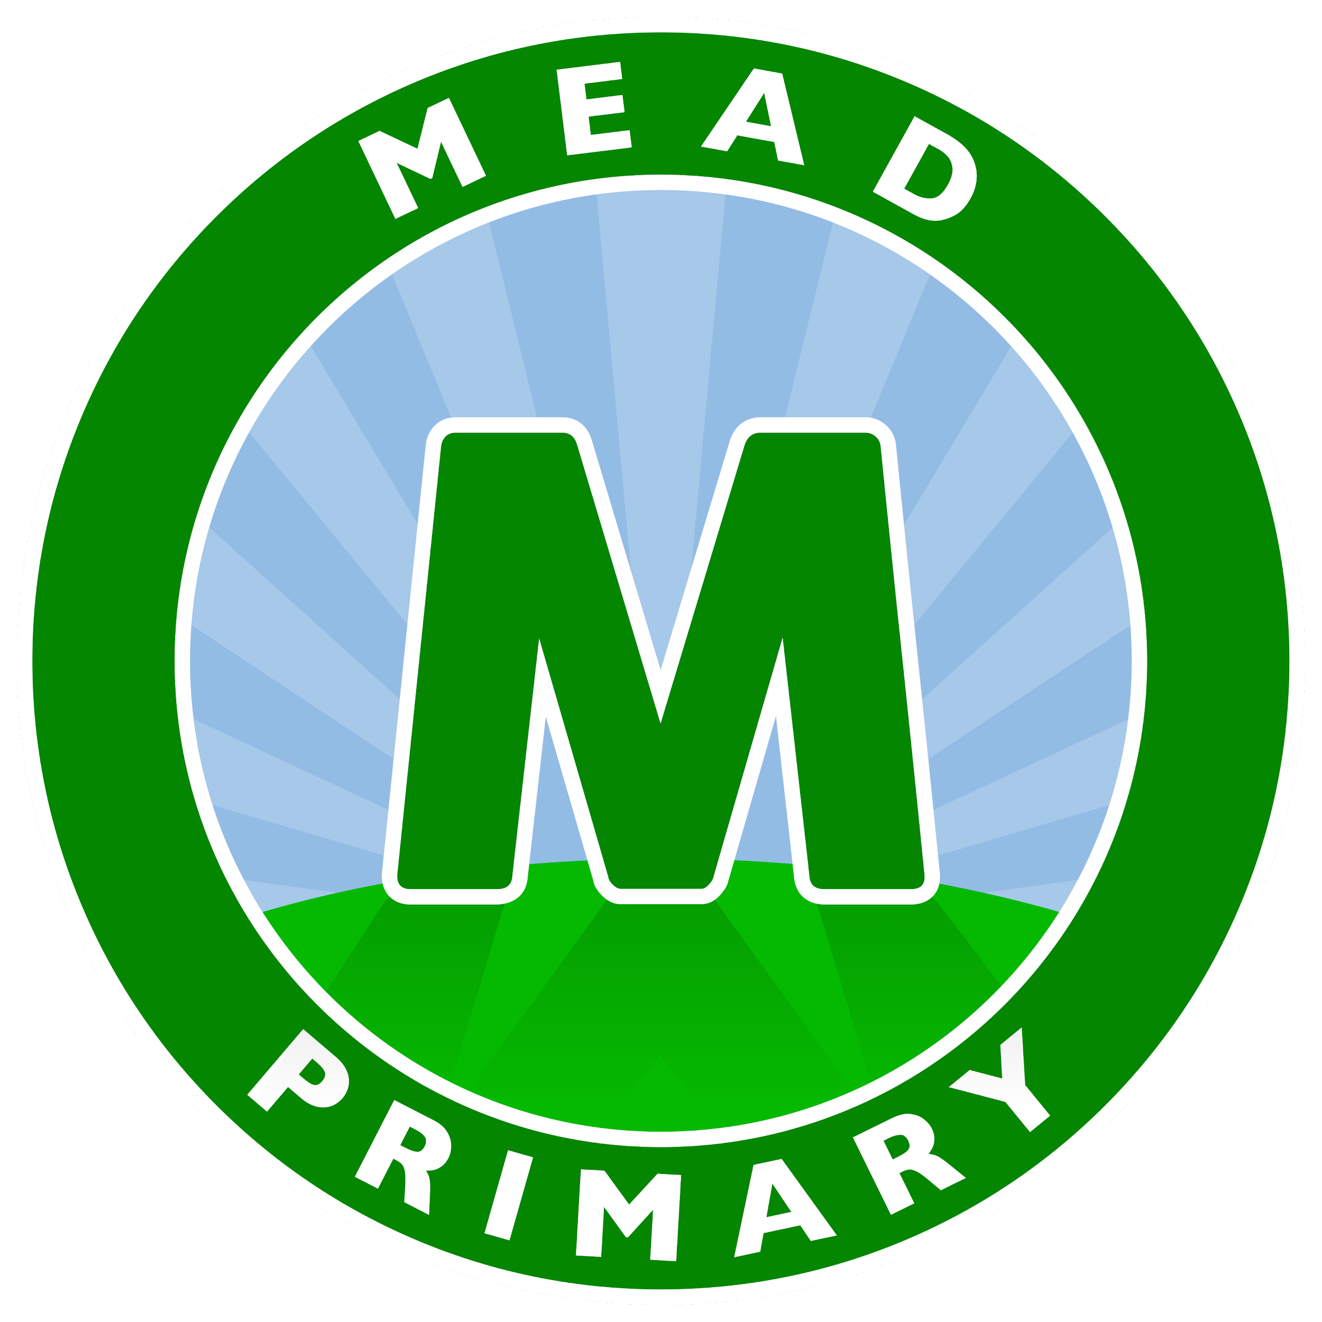

Executive Head teacher: Mr D Denchfield
Head of School: Ms A Holmes

Weekly Newsletter (Section1 - Important Information)
Friday 18th March 2022

Dear Parents and Carers,

Parents Evening
Parents Evening appointments were sent out last week on School Ping. In order to book a time all you need to do is select the time slot you wish for your child and this will automatically reserve your space. If you are having trouble with this please speak to your child’s class teacher. If you have not signed up to this service please speak to Mrs Parker in the school office.

UNICEF Ukraine Appeal
Thank you to you all for generously donating coins to the Ukraine Appeal which has been organised by the school pupil parliament. They will be continuing to collect donations next week.

Message from Pupil Parliament:
At Mead, we are so lucky to be able to be in school whereas lots of children in Ukraine are unable to attend school due to the current conflict. We decided that we would like to support children who are suffering by donating to UNICEF. For every £80 raised, UNICEF can support 20 children so they can continue their education. We would like everyone to bring in spare change (as much as you can). We will be collecting donations throughout the week. Let’s see how many children we can help!

School Uniform and PE Kit
A reminder that all children should be wearing the correct school uniform and PE kit in school. Some of you my have recieved a letter this week regarding PE kits. Children re bike to wear green or black shorts of any style. Please also make sure that your child has suitable footwear.

Key Information and dates
School Ping Squid login
Havering Catering Lunch Menu

Monday 28th March Parents Evening
Tuesday 29th March Parents Evening
Wednesday 18th May Parent Partnership Meeting in KS2 Hall at 9am (Homework) Thursday 30th June Parent Partnership Meeting in KS2 Hall at 9am (Understanding SEN)

Yours sincerely,
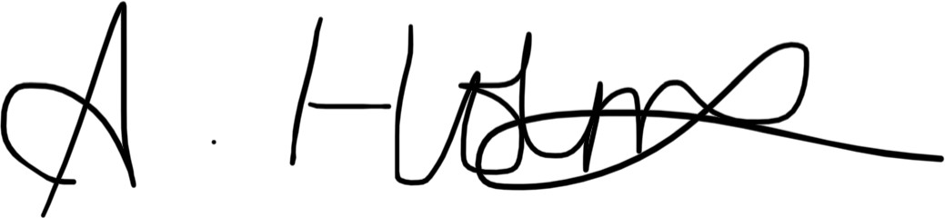

Ms A Holmes Head of School

Weekly Newsletter (Section 2 - Amazing Awards!)

Achievement Certificates
Well done to this week’s Achievement Certificate winners who are Emma (Kenya), Bella-Leigh and Tilly (Germany) Aisha and Shay (Madagascar).

Malta’s Star of the Week
Many congratulations to Jackson who has been awarded Malta’s Star of the Week for completing his workstation tasks straight away, every day this week.

Star Writer Certificates
These children have excelled with their writing this week. Well done to Arsalaan (Kenya), Melisa (Malaysia), Azrah (Barbados), Alex (Scotland), Fareeda (Italy), Jaion (Germany) Alfie (India), Ruby (Fiji), Frankie (Wales), Ahmed (Antigua), Avyukt (Madagascar), Cristian (Northern Ireland), Shree, Nathan N and Amelia (Australia), Chloe (Greece), Kamil (Palau), Ria (Egypt), Georgie-Mai (USA), Albert (Mexico), Kai (Singapore) Olivia H (New Zealand), Ruby-Lea (St Lucia) and Rianne (Brazil), Nicole (China).

Star Reader Certificates
These children have worked really hard on their reading this week. Well done to Amaan (Kenya), Dinuki (Malaysia), Esther (Barbados), Todor, Theodora (Scotland), Olivia (Italy), Summer (Germany), Aaliyah (India), Oscar (Fiji), Isabel (Wales), Yousif (Antigua), Esther (Madagascar), Elda (Northern Ireland), Stephanie (Australia), Haydar (Greece), Emilia (Palau), Amin (USA), Connie (Mexico), Donovan (Egypt), Julia (Singapore), Violet (New Zealand), Harry (St Lucia) and Kevin (Brazil), Daniela (China).

Star Mathematician Certificates
These children have enjoyed a fantastic week with their maths. Well done to Emma (Kenya), Alexa (Malaysia), Isla (Barbados), Muhammad (Scotland), Esmai (Italy), Rio (Germany), Olivia (India), Rosie (Fiji), Tyler (Wales), Mujeeb (Antigua), Aum (Madagascar), Ty (Northern Ireland), Nathan K (Australia), Paige (Greece), Bella, Kajus (USA), Harley (Mexico), Jesse (Singapore), Sidiq (Egypt) Akhila (New Zealand), Leo (Barbados) and Tommy C (Brazil), Antoinette (China).

Mathletics Award
Suljeman (China), Olivia (India), Rehan (Malaysia), Zahi, Jack, Julia, Austeja (Singapore), Layla, Merkhima, Todor, Daniel K, Majus, Alex, Daniel R, Max, Olivia and Sophie (Italy), Hollie, Poppy, Grace, Leo, Avyukt, Taylor, Aum, Leya & Shay (Madagascar), Azrah, Ella, Alicia, Noura, Jake, Rayne, Albert, Dawood, Sara, Ethan (Barbados), Sydney, Lavinia and Evie (Antigua), Sidrah, Amy, Ria, Izabela and Zuzanna (Egypt), Vlad, Elda, Kaden, Nevaeh & Anna (Northern Ireland), Evie, Tehzeeb, Jokubas, Tilly, Sofia (Germany), Michael N (Greece), Olivia, Kamil, Zelda, Emilia, Sebastian and Domas (Palau), Kavi, Stephanie, Jessica and Nancy.
Bronze certificate

 | Nathan K and David T (Australia), Anastasia, Kajus and Vansh (USA), Manvik (Mexico), Rayan, Zakariya, Victoria and Manha (Fiji), Inaya, Callum, Justas, Oguzcan, Lenny M, Akhila (New Zealand), Umer and Stefan (St Lucia) Lukas, Charlotte, Rosie, Tommy C, Daisy, Kevin, Simeon, Rahat, Vanya, Remi, Sofia, Charlie, Chas and Jasmine (Brazil)
Silver certificate | Suljeman (China), Olivia (India), Julia, Austeja (Singapore), Daniel K, Alex (Scotland) Hollie and Shay (Madagascar), Jake (Barbados), Donovan, Dora, Amber and Ella (Egypt), Vlad (Northern Ireland), Domas (Palau), Kavi (Australia), Vansh (USA), Rayan (New Zealand), Manha (Fiji) Rahat, Vanya, Sofia and Charlie (Brazil)
Gold certificate | Olivia (India), Daniel K (Scotland) Hollie (Madagascar), Jake (Barbados), Ignacy (Egypt) and Henry (New Zealand)

Golden Certificate
Congratulations to these children who have been awarded a Golden Certificate as they have made exceptionally good choices linked to The Mead Creed. These certificates are not easy to get so very well done to this week’s winners!
Malta (ARP) |  | England (YN)
Barbados (YR) |  | St Lucia (YR)
Antigua (YR) | Grace and Sydney | New Zealand (Y1) | Abira
Palau (Y1) | Zion-Elijah | Fiji (Y1)
Australia (Y1) | Afonso and David D | Madagascar (Y2) | Lorena
Kenya (Y2) | Noah and Aubree | Egypt (Y2)
Scotland (Y3) | Majus, Paulina, Maria | Wales (Y3) | Gracie
Northern Ireland (Y3) | Vilte, Alannah & Amaliah | Italy (Y4) | James and Katherine
Greece (Y4) | Haydar and Junior | Germany (Y4) | Isabella and Jaion
Brazil (Y5) | Sofia, Nicole, Remi | Mexico (Y5) | Andy, Nathanuel, Alex and Katie
USA (Y5) | Olivia and Stephen | India (Y6) | Sonny, Larkenz, Lily-Rae
China (Y6) | Dollie, Sade, Sulejman, Summer, Lena, Alfie, Faaiz | Malaysia (Y6) | Lenny, Dinuki, Brooke D, Jake
Singapore (Y6) | River, Zainab, Preston, Helena

Attendance-opoly
Well done to Egypt, Greece, Mexico, Brazil and Singapore who have met their attendance target and were able to roll the dice!

Congratulations to everyone who achieved an award this week, we are very proud of you!

