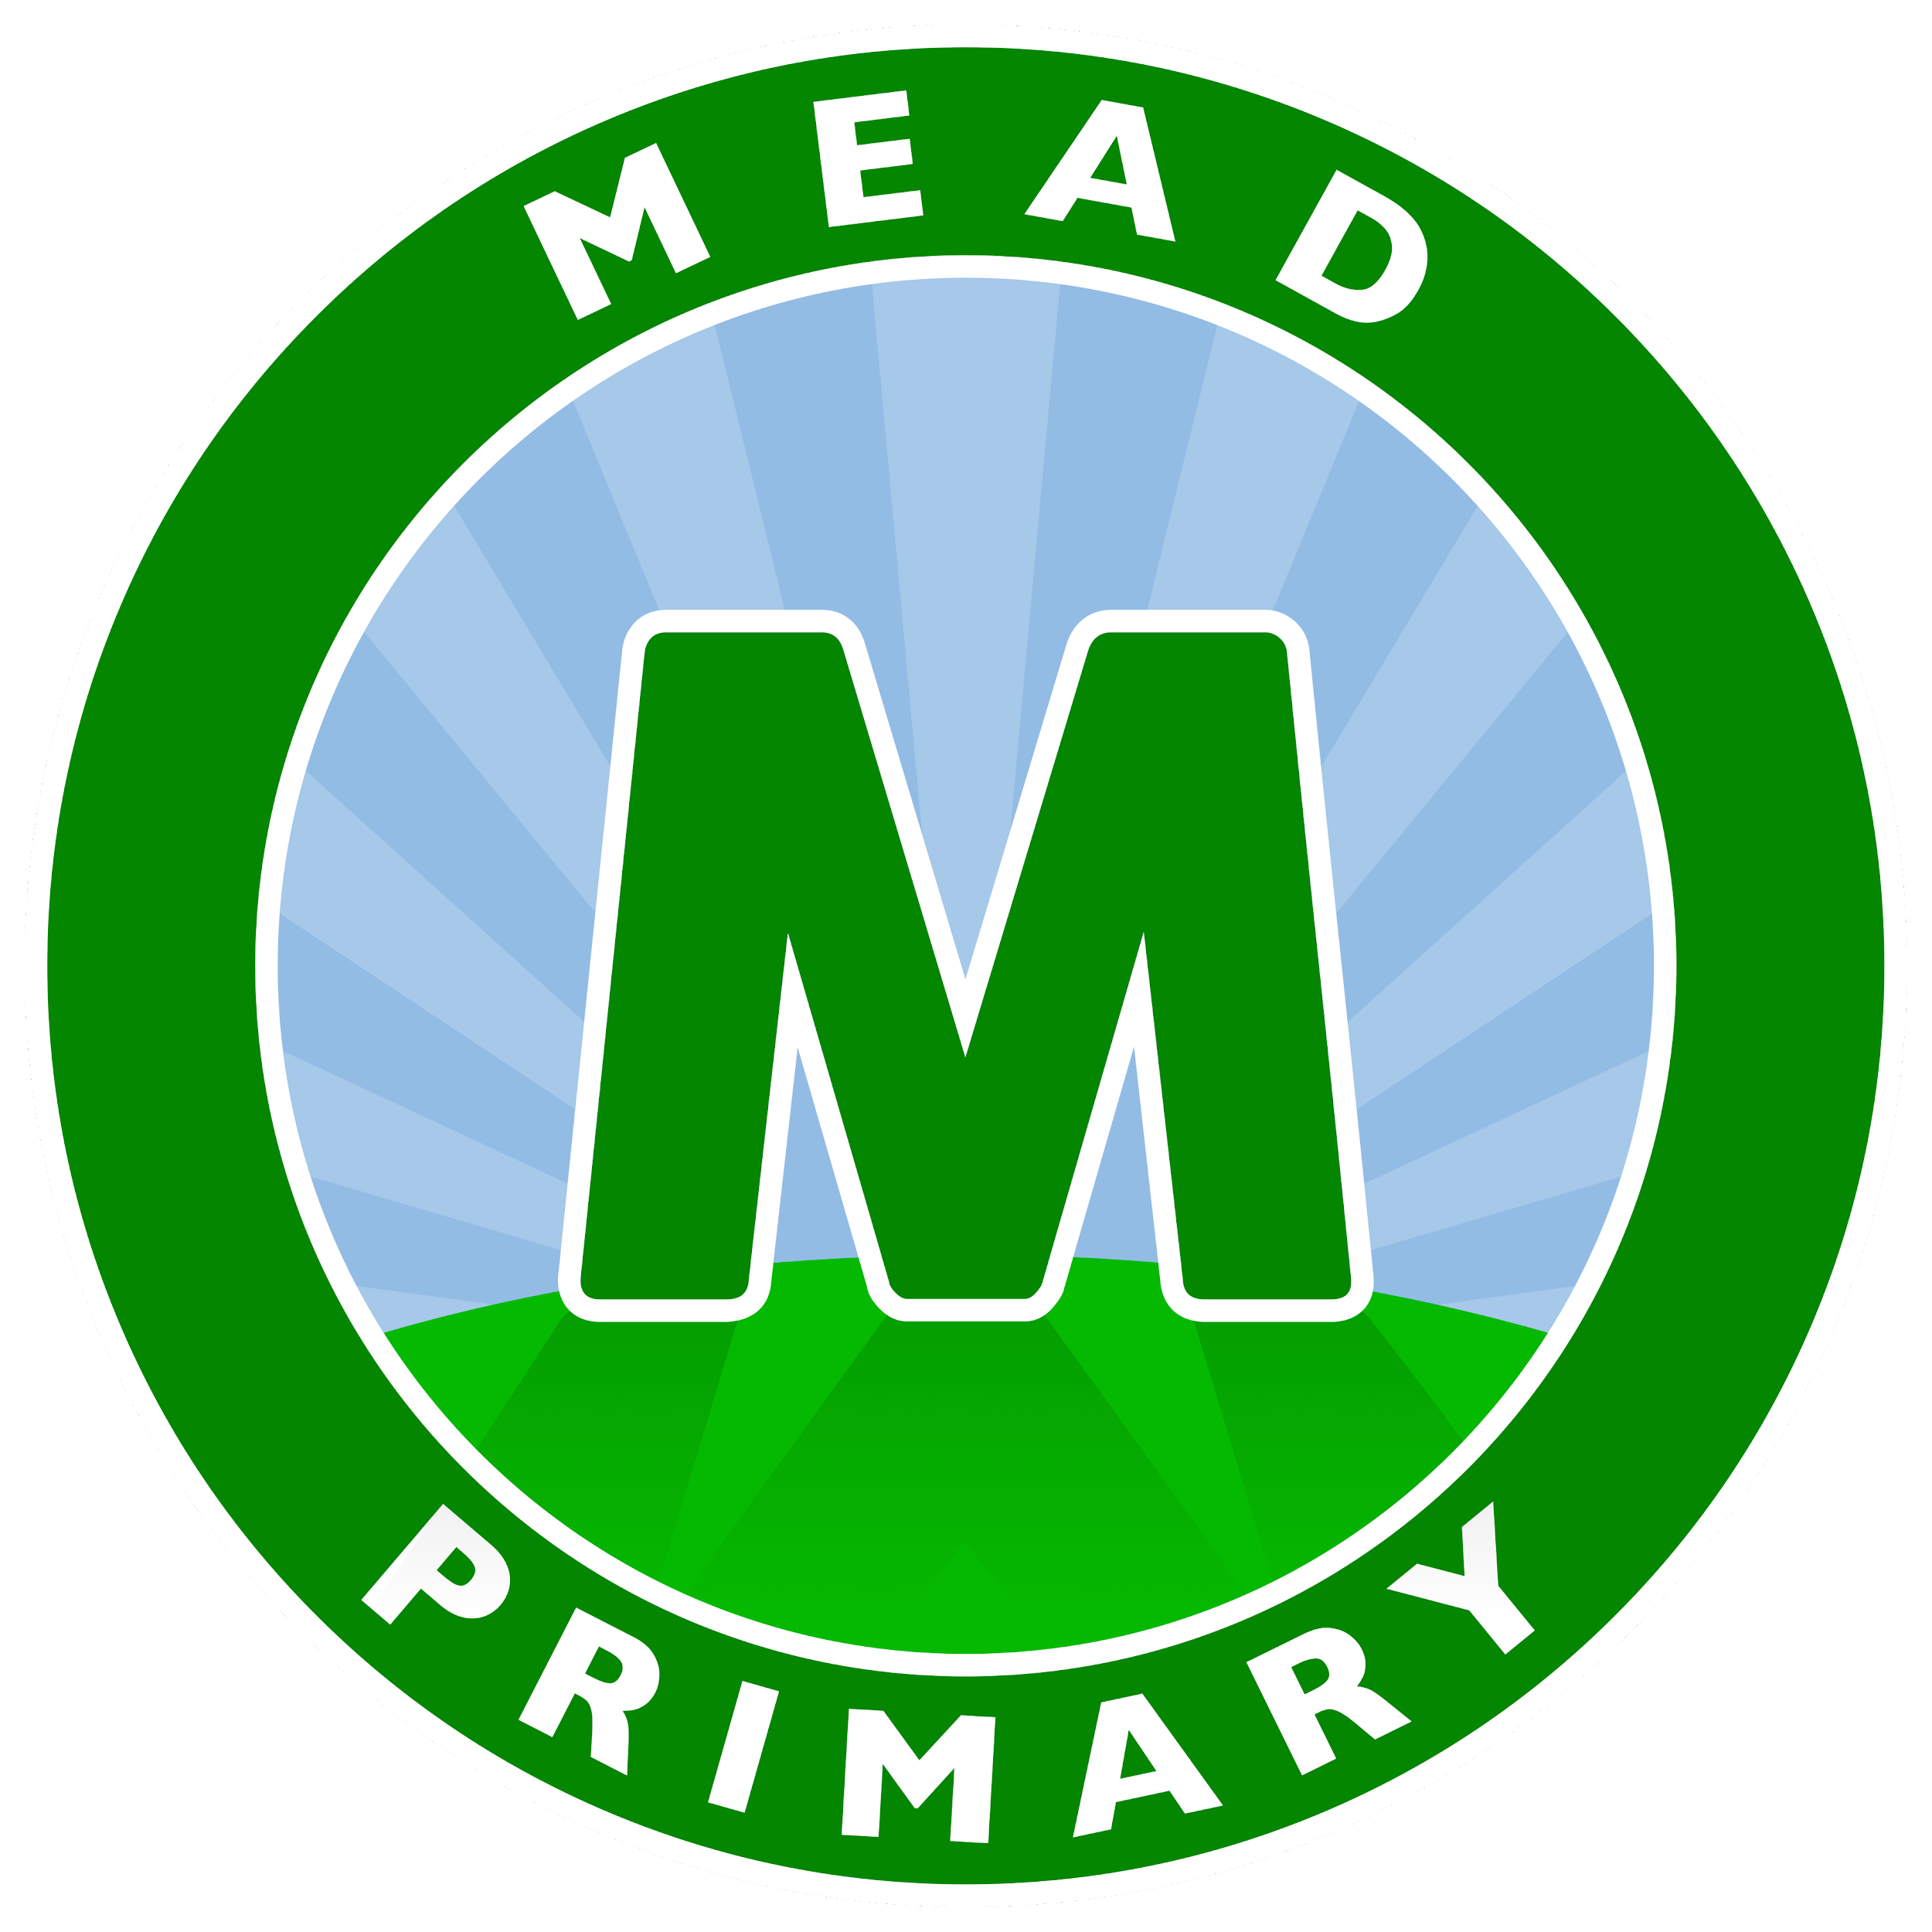

Executive Head teacher: Mr D Denchfield
Head of School: Ms A Holmes

Weekly Newsletter (Section1 - Important Information)
Friday 11th March 2022

Dear Parents and Carers,

Parents Evening
This year we are booking appointments through the School’s Ping account. You will receive an invite today through a text message. In order to book a time all you need to do is select the time slot you wish for your child and this will automatically reserve your space. If you are having trouble with this please speak to your child’s class teacher.

Parent Partnership Meeting
Yesterday we held our second Parent Partnership meeting which was focused on Phonics and Reading. Thank you to those who attended. Our next meeting will be on Wednesday 18th May and will be focussed on Homework and ways to support your child at home. We look forward to seeing you then.

Romford Recorder
The Romford Recorder has published some of Mead’s photographs from World Book Day in today's addition - make sure you grab a copy!

Parking
Please make sure that you are parking mindfully and with respect for our school neighbours. Parking across driveways must be avoided, even if this is for a short amount of time.

School Uniform and PE Kit
A reminder that all children should be wearing the correct school uniform and PE kit in school.

Key Information and dates
School Ping Squid login
Havering Catering Lunch Menu

Monday 28th March Parents Evening
Tuesday 29th March Parents Evening
Wednesday 18th May Parent Partnership Meeting in KS2 Hall at 9am (Homework) Thursday 30th June Parent Partnership Meeting in KS2 Hall at 9am (Understanding SEN)

Yours sincerely,
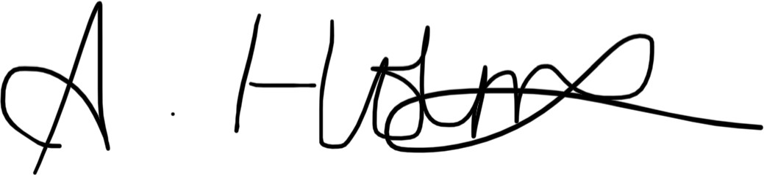

Ms A Holmes Head of School

Weekly Newsletter (Section 2 - Amazing Awards!)

Achievement Certificates
Well done to this week’s Achievement Certificate winners who are Emilia (Kenya), Natalia and Grace(Madagascar), Evelin (Scotland), Ellie-Maie and Jokubas (Germany)

Malta’s Star of the Week
Many congratulations to Bella who has been awarded Malta’s Star of the Week for good looking and listening in PE.

Star Writer Certificates
These children have excelled with their writing this week. Well done to Ryan (Kenya), Joanna and Mahir (Australia), Ethan (Barbados), Jessica (Malaysia), Khasim (Fiji), Aisosa (Antigua), Gracie(Madgascar), Robbie (Scotland), Amira (Northern Ireland), Darius (Egypt), Mya (Singapore), Charlotte F (Wales), Amirah (Palau), Natas (Greece), George (Italy) Francesca (Mexico), Tehzeeb (Germany) Larkenz (India), Livi (New Zealand), Olivia-Rose (USA), Maddison-Rose (St Lucia) and Milana (China).

Star Reader Certificates
These children have worked really hard on their reading this week. Well done to Mekhi (Kenya), Emaan (Australia), Nikole (Barbados), Ben (Malaysia), Yoyinsola (Fiji), Shay and Samir (Madagascar), Ahmed (Antigua), Evelin (Scotland), Vlad (Northern Ireland), Dora (Egypt), Zainab (Singapore), Tyler (Wales), Camelia (Palau), Tommy (Greece), Oghomwen (Germany), Elizabelle (Italy), Andy (Mexico), Alfie (India), Sophie (New Zealand), Michael (USA), Jose (St Lucia) and Kiyah (China).

Star Mathematician Certificates
These children have enjoyed a fantastic week with their maths. Well done to Kajus (Kenya), Tommy-Sean (Australia), Dawood (Barbados), Jake (Malaysia), Sethika (Fiji), Blake (Antigua), Dempcee (Scotland), Nevaeh (Northern Ireland), William (Egypt), ameron (Singapore), Maryam (Wales), Kojo (Palau), Luka (Greece), David (Italy), Sofia (Germany), Ordrey (Mexico), Brea (India) Evelyn (New Zealand), Vansh (USA), Nevaeh (St Lucia) and Daniel (China).

Mathletics Award
Bronze certificate | Jessica, Nathan K, David T, Stephanie and Kavi, Azrah, Alicia, Esther, Noura, Albert, Sara, Ethan,Nikole and Jake (Barbados)Taha, Arsalaan, Layla, Nuhaa, Emma, Roman G, Izyan and Mia (Kenya), Suljeman (China), Olivia (India), Emily, Rehan (Malaysia), Zahi, Austeja, Julia (Singapore), Aisha, Malakai, Natalia, Grace, Hollie, Shay (Madagascar), Ella, Victoria, Manha, Skyla (Fiji), Muhammad, Layla, Merkhima, Evelin, Todor, Daniel K, Majus, Daiel R (Scotland), Vlad, Cristian, Kaden, Samuel and Saim (Northern Ireland), Amy, Domas, Ria, Izabela, Donovan, Dora, Amber and Ella (Egypt), Penelope & Lavinia (Antigua), Olivia, Domas, Zelda, Zofia, Emilia and Sebastian (Palau), Gabriel, Haydar and Michael N (Greece) Henry, Oguzcan, Amelia H, Lenny M and Rayan (New Zealand), Evie, Jacob and Jokubas (Germany), Anastasia, Kajus & Vansh (USA), Max, Sophia and Zachary (Italy).
Silver certificate | Jessica and Nathan K (Australia), Azrah, Nikole (Barbados) Taha, Arsalaan (Kenya), Grace, Avyukt, Aum, (Madgascar), Ella (Fiji), Evelin (Scotland), Sidrah

 | and Zuzanna (Egypt), Sebastian (Palau), Haydar (Greece), Justas and Akhila (New Zealand), Evie (Germany) and Anastasia (USA).
Gold certificate | Taha (Kenya) and Leya (Madagascar).

Golden Certificate
Congratulations to these children who have been awarded a Golden Certificate as they have made exceptionally good choices linked to The Mead Creed. These certificates are not easy to get so very well done to this week’s winners!
Malta (ARP) |  | England (YN)
Barbados (YR) |  | St Lucia (YR) | Phoebe and Ja’c
Antigua (YR) |  | New Zealand (Y1)
Palau (Y1) |  | Fiji (Y1) | Skyla
Australia (Y1) | Kavi | Madagascar (Y2) | All of the class for their hard work this week
Kenya (Y2) | KENYA CLASS! | Egypt (Y2) | Egypt for their amazing work this week!
Scotland (Y3) | Paulina | Wales (Y3) | Isabel
Northern Ireland (Y3) | Amen | Italy (Y4) | Arwyn and Riley
Greece (Y4) | Bailey, Jake and Millie | Germany (Y4) | Maya, Sofia, Bella-Leigh, Archie, Jared, Tehzeeb
Brazil (Y5) |  | Mexico (Y5) | Caiden
USA (Y5) | Vansh | India (Y6) | Lily-Rae, Logan
China (Y6) |  | Malaysia (Y6) | Dinuki, Melisa, Alexa, Emily, Taylor, Jake, Lenny, Tyler, Rehan, Hayden, Jessica
Singapore (Y6) | Austeja, Jack

Attendance-opoly
Well done to Palau, Fiji, N. Ireland, Mexico and Singapore who have met their attendance target and were able to roll the dice!

Congratulations to everyone who achieved an award this week, we are very proud of you!

