Weekly Newsletter (Section1 - Important Information)

Friday 25th February 2022
Dear Parents and Carers,
Welcome back after the half term break. We have been off to a flying start this half term and the children have settled back into the routines of school and are working hard.
The 2 Johns E-Safety- Parent Partnership Meeting
This week Parents, children and staff were fortunate enough to participate in an e-safety workshop. The workshop gave pupils, parents and staff a better understanding of how to stay safe and support children online without restricting the use of technology. It is important to know what to do and say to support our children whilst also preparing them for the digital world. Further information, help and support can be found here https://esafetytraining.org/resources/parents-carers-area/ .

Our next Parent Partnership Meeting will focus on Phonics and Reading and will be held on Thursday 10th March at 9am in the KS2 hall. All parents and carers are invited to attend.

ABACUS After school club
We are looking to provide after school care through ABACUSafter school club. Please complete the link below to register interest in ABACUS after school club and ask questions about the provision. https://forms.gle/RmTj6Vm9nMrPuvid7

World book day
We will be celebrating World Book day on Thursday 3rd March. This year we are also celebrating the 25th anniversary of World Book Day – with the message for all children ‘you are a reader‘! It will be filled with lots of exciting, celebratory ways to promote reading for pleasure on World Book Day, and all-year round. On this day children will be able to come to school dressed as their favorite book character.

Staff Car Park
Please refrain from using the staff car park, particularly when dropping children off to morning clubs.

Lunch Menus
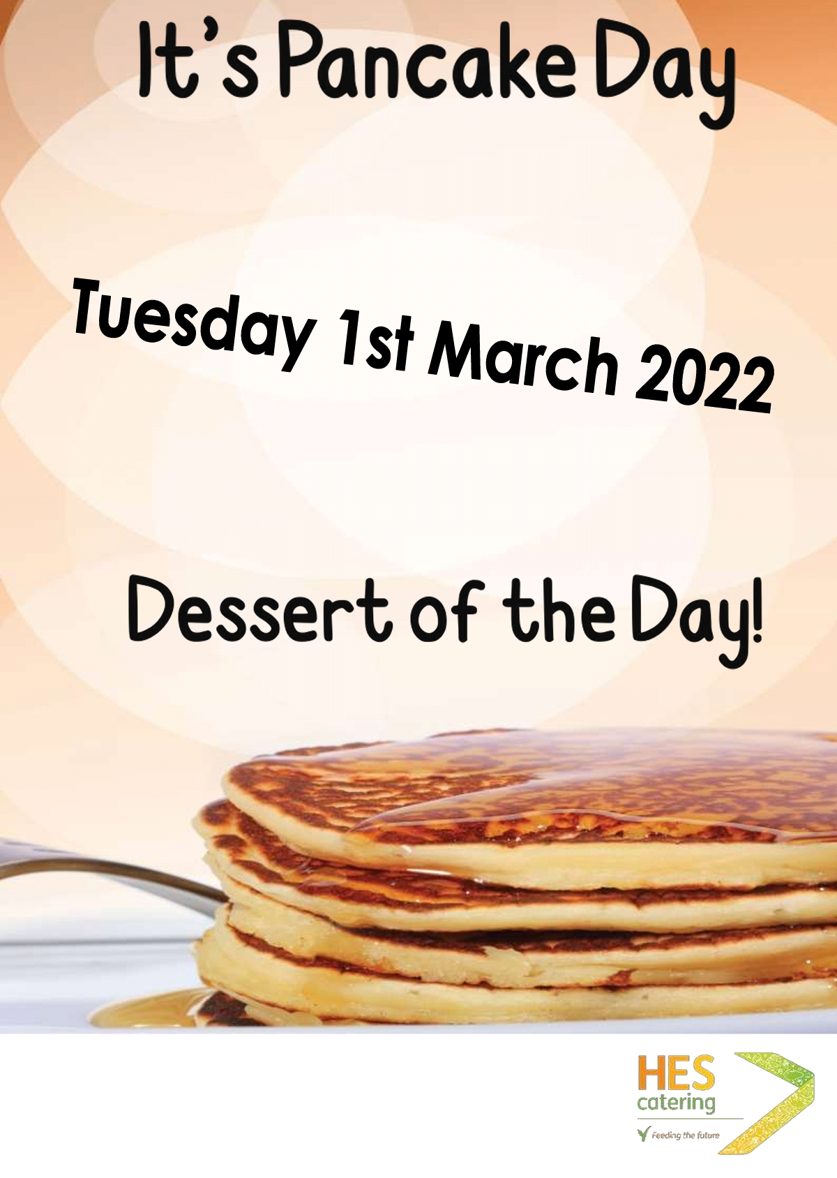
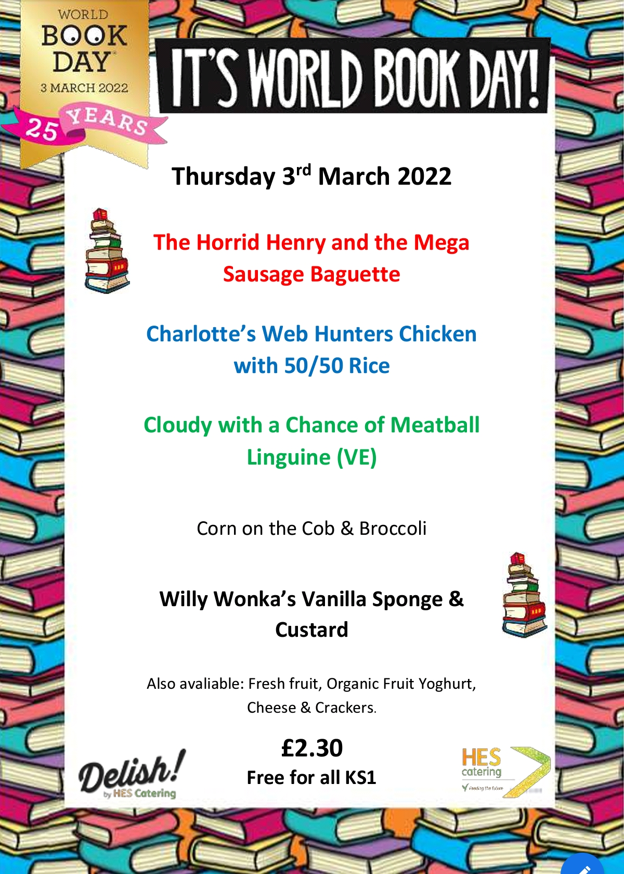
There will be changes to the school menu on Tuesday 1st March and Thursday 3rd March.

Key Information and dates
School Ping
Squid login
Havering Catering Lunch Menu

Thursday 3rd March World Book Day
Thursday 10th March Reading and Phonics Parent Partnership Morning in the KS2 hall at 9am
Monday 28th March Parents Evening (more information to follow)
Tuesday 29th March Parents Evening (more information to follow)

We hope that you have a wonderful half term break. We look forward to seeing you back in school on Tuesday 22nd February.

Yours sincerely,
Ms A Holmes
Head of School

Weekly Newsletter (Section 2 - Amazing Awards!)
Achievement Certificates
Well done to this week’s Achievement Certificate winners who are Chloe (Germany), Lorena, Logan, Ralph, Lyra(Madagascar) and Iziah (Scotland).

Malta’s Star of the Week
Many congratulations to Gracie who has been awarded Malta’s Star of the Week for completing her workstation tasks independently.

Star Writer Certificates
These children have excelled with their writing this week. Well done to Emaan (Australia), Ty (Northern Ireland), Aubree (Kenya), Cattleya (Greece), Samuil (Barbados), Matvejs (Malaysia), Arwyn (Italy), Mickey-Ray (Wales), Dragos (Antigua), Jared (Germany), Milena (Palau), Evelyn (New Zealand), Poppy (Madagascar), Muhamad (Scotland), Amy (Egypt), Helena (Singapore), Sulejman (China), Layla-Mai (Mexico), Ender (Fiji), Olivia-Rose (St Lucia), Michael (USA), Afnan (India) and Charlie (Brazil),

Star Reader Certificates
These children have worked really hard on their reading this week. Well done to Amira (Northern Ireland), Andrew (Kenya), Gabriel (Greece), Roman (Barbados), Benjamin (Malaysia), Gracie (Wales), Bentley (Italy), Isaiah (Antigua), Sofia (Germany), Dennie (Palau), Lenny M (New Zealand), Natalia and Samhita (Madagascar), Layla (Scotland), Daisy-Rose (Egypt), Preston (Singapore), Lily (Australia), Faaiz (China), Adam (Mexico), Georgia (Fiji). Tillie (St Lucia), Nathan (USA), Dominik (India) and Tommy C (Brazil),

Star Mathematician Certificates
These children have enjoyed a fantastic week with their maths. Well done to Samuel (Northern Ireland), Taha (Kenya), Destini (Greece), Lina (Barbados), Melisa (Malaysia), Levi (Wales), Sienna (Italy), Archie (Germany), Aisosa (Antiguia), Amelia (Palau), Nubian (New Zealand), Kane (Scotland), Ella (Egypt), Kai (Singapore), Kavi (Australia), Jay-Jay (China), Zakariya (Fiji), Alexander (Mexico), Rocco (USA), Michael (St Lucia), Lily-Rae (India) and Remi (Brazil),

Mathletics Award
Bronze certificate | Stephanie, Jessica, David T, Kavi and Nathan K (Australia), Vlad, Kaden and David (Northern Ireland) Andrew, Arsalaan, Moksha, Nuhaa, Emma, Karl, Izyan, Ryan, Charley, Lucille, Taha, Alexa, (Kenya), Michael N (Greece), Azrah, Alicia, Esther, Noura, Albert, Dawood, Sara, Ethan, Nikole, Jake (Barbados), Sydney, Talula and Milena (Antigua), Evie, Jacob, Jokubas. Oghomwen, Sofia and Jared (Germany) Inaya, Justas, Oguzcan, Lenny L, Akhila and Rayan (New Zealand), Olivia, Emilia, Camelia, Domas, Zelda, Zofia, Sebastian (Palau)Malakai, Samir, Natalia, Isla, Grace, Hollie, Andrey, Leo, Avyukt, Aum, Leya, Shay (Madagascar), Suljeman and Nicole (China), Olivia (India), Rehan and Benjamin (Malaysia), Jolin, Zahi, Austeja (Singapore), Daniel K, Majus, Alex, Daniel O, Daniel R (Scotland), Sidrah, Amy, Domas, Ria, Donovan, Ignacy, Dora, Zuzanna, Amber, Fausta, Shayan and Ella (Egypt), Ender, Skyla, Kelsie, Zakariya, Lillie and Manha (Fiji), Kajus (USA), Anastasia (USA), Lukas, Rosie, Vanya, Charlie, Ella and Jasmine (Brazil)
Silver certificate | Stephanie (Australia), Olivia, Emilia (Palau), Nuhaa, Emma, Charley, (Kenya), Michael N (Greece), Albert (Barbados), Miliena and Sydney (Antigua), Evie, Jacob, Sofia and Jokubas (Germany) Lenny M , Benjamin (Malaysia), Zahi (Singapore), Majus, Daniel R (Scotland), Janvi (Egypt), Ender and Zakariya (Fiji) and Kajus (USA)
Gold certificate | Nuhaa (Kenya), Albert (Barbados), Jokubas and Jacob (Germany), Zakariya (Fiji), Ava and Isaiah (Antigua)

Golden Certificate
Congratulations to these children who have been awarded a Golden Certificate as they have made exceptionally good choices linked to The Mead Creed. These certificates are not easy to get so very well done to this week’s winners!
Malta (ARP) | Joseph | England (YN)
Barbados (YR) |  | St Lucia (YR)
Antigua (YR) |  | New Zealand (Y1)
Palau (Y1) | Charlie | Fiji (Y1) | Riley
Australia (Y1) |  | Madagascar (Y2) | Samir
Kenya (Y2) | Emma and Nuhaa | Egypt (Y2) | Sandra, Donovan, Domas, Ria and Zuzanna
Scotland (Y3) | Bella | Wales (Y3) | Josh, Indigo
Northern Ireland (Y3) | Eduard, Amaliah and Zaydh | Italy (Y4) | Sienna and Zachary
Greece (Y4) | Junior | Germany (Y4) | Chloe
Brazil (Y5) | Dovydas, Kevin, Kajus, Lukas, Remi, Jasmine | Mexico (Y5) | Tegan
USA (Y5) | Lileerae & Louie | India (Y6) | Ellie, Harry, Logan
China (Y6) | Milana, Nicole, Famata, Kiyah & Daniela | Malaysia (Y6)
Singapore (Y6) | Felicity & Jolin

Attendance-opoly
Well done to Malta and USA who have met their attendance target and were able to roll the dice!

Congratulations to everyone who achieved an award this week, we are very proud of you!

