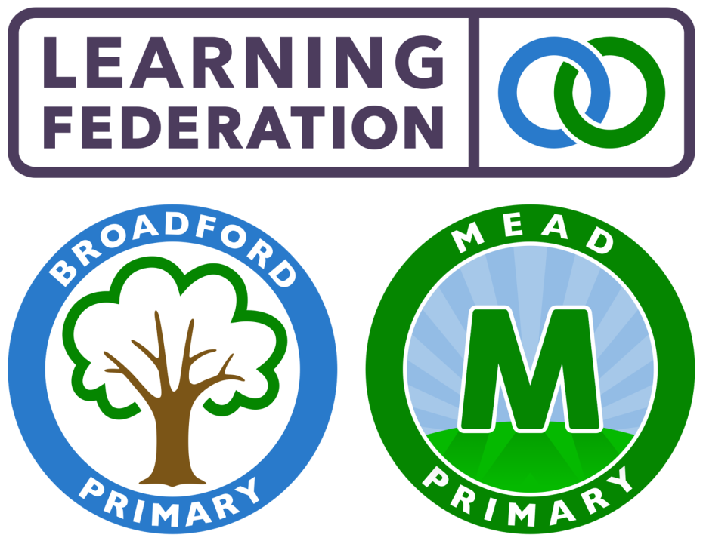
Mead Pupil Premium Strategy Statement

2021 – 2022

This statement details our school’s use of pupil premium (and recovery premium for the 2021 to 2022 academic year) funding to help improve the attainment of our disadvantaged pupils. It outlines our pupil premium strategy, how we intend to spend the funding in this academic year and the effect that last year’s spending of pupil premium had within our school.

The EEF (Education Endowment) Toolkit was used alongside what has worked previously in school when deciding the evidence or rationale of the school’s action. Red shows the impact in months from research of our chosen activity.

See link for further information https://educationendowmentfoundation.org.uk/evidence-summaries/teaching-learning-toolkit/

School overview
Detail | Data
School name | Mead Primary School
Number of pupils in school (Year R to Year 6) | 650
Proportion (%) of pupil premium eligible pupils | 39% (255)
Academic year/years that our current pupil premium strategy plan covers | 2021-2024
Date this statement was published | November 2021
Date on which it will be reviewed | September 2022
Statement authorised by | David Denchfield
Pupil premium lead | Amy Holmes
Governor lead | Alan Kemp
Funding overview
Detail | Amount
Pupil premium funding allocation this academic year | £282,220
Recovery premium funding allocation this academic year | £17,925
Pupil premium funding carried forward from previous years (enter £0 if not applicable) | £24,932
Total budget for this academic year | £325,077

Further School Context
To narrow the attainment gap between disadvantaged and non-disadvantaged pupils nationally and within internal data.
School Objective
- We are a considerably larger than average primary school which serves the Gooshays Ward and wider Harold Hill community. We currently have 650 children on roll in Years R to 6 with an additional 86 nursery pupils.
- The Gooshays Ward which is an area of deprivation and in places with considerable social challenge.
- Children under 16 living in families with relatively low income is over 32% higher than the Havering average and children under 16 living in families with absolute low Income is over 33% higher than the Havering average. Fuel poverty and out of work benefits are also similarly higher. Havering Data Intelligence Hub Report
- We are a 3FE school which is currently undertaking building work to expand to 4FE. Currently, our Y1 cohort is 4FE with future 4FE year groups planned for September 2022 (starting with Reception). When full, we will have 912 children on roll.
- We have two part time nursery sessions (am and pm) which offer 120 sessions across the day.
- We have an Alternative Resource Provision for 12 autistic children (some pre-verbal).
- 38% (246/650) of our children receive FSM.
- 26.5% (197/736) of our children are EAL & speak 34 different languages. This has steadily increased over the last 3 years.
- 11.1% (82/736) of our children are on the SEN register and 3.8% (28/736) have an EHCP.

Part A: Pupil premium strategy plan

Statement of intent

Our aim is that all children, regardless of their socio-economic background can flourish, both academically and socially. We believe that the best way to remove barriers for disadvantaged children and to ensure that they are able to reach their full potential is through the delivery of a challenging and enriching curriculum. Our pupil premium strategy is focused on ensuring that disadvantaged children leave school with the same knowledge, skills and qualifications as their peers. The strategy therefore centres on high quality teaching, with the provision of targeted academic support and wider strategies to improve parental engagement.

Challenges

This details the key challenges to achievement that we have identified among our disadvantaged pupils.
Challenge number | Detail of challenge
1 | Low attainment and slow progress rates made by pupil premium/disadvantaged children in all Key Stages.
2 | The children have gaps and misconceptions and find it difficult to retain/recall prior knowledge.
3 | Pupils have limited experiences beyond their home life and immediate community.
4 | Language and communication on entry to school is below age related expectation which inhibits the progress of pupil premium children in all areas of the curriculum.
5 | Low attendance and persistent absenteeism of PP/disadvantaged children.
6 | Pupils and their families have social & emotional difficulties, including financial, medical and mental health issues.

Intended outcomes
This explains the outcomes we are aiming for by the end of our current strategy plan, and how we will measure whether they have been achieved.
Intended outcome | Success criteria
Disadvantaged pupils maintain at least the standard of attainment they achieved at the end of the previous year (Reading, Writing and Maths) and previous key stage; those who have ‘fallen behind’ make accelerated progress and ‘catch up’ or exceed prior attainment standards.  To ensure fallen behind children receive targeted high quality intervention monitored by intervention leader. | End of summer 2023 data will show that disadvantaged children exceed prior attainment standards.  Phonics- Achieve in line with national average expected in Phonics Screening Check  Reading- Achieve in line with national average progress scores in KS2 Reading  Writing- Achieve in line with national average progress scores in KS2 Writing  Maths- Achieve in line with national average progress scores in KS2 Maths  Analysis of interventions will show that interventions have had a positive impact on the disadvantaged children’s learning and have helped in accelerating their progress.
Pupils have a breadth of experiences that enable them to contextualize their learning.  School will deliver an engaging, broad and varied curriculum. | Changes to and further clarity of curriculum intent and implementation will provide pupils with exciting, skills based and knowledge rich learning experiences.  Ongoing monitoring, including pupil questionnaires (Summer 2) will show that children enjoy school and are enthused to learn more.  We will have instilled a love of learning and independence to lead learning in all children.  Teachers and support staff will plan a wide range of enrichment visits/ events/experiences to inspire/enhance learning and make it memorable.  Each year group will spend allocated funding on providing enrichment days and events which excite and engage children to learn across all subjects.  Children will be exposed to a wide range of social, cultural, enrichment and sporting experiences within (and outside) the school day.
All disadvantaged/PP pupils identified on entry with language and communication difficulties will be supported through targeted speech and language intervention | Staff will be allocated time to undertake training and deliver Speech and Language intervention.  All EYFS staff will be engaged with Speech and Language intervention to support children.  In year data from Baseline assessments will show that all PP/disadvantaged children are in line with non PP peers.  Parental engagement is increased to instil the important role parents and carers have in developing communication and language
All disadvantaged pupils will meet national expectations for attendance/persistent absence. | Disadvantaged pupils will match national attendance averages for non-disadvantaged pupils (96+%).  Monitoring of attendance by Head of School and Senior Learning Mentor brings about an increase in PP pupils’ attendance and a decrease in persistent absence.  Breakfast club provision in place for pupils to encourage attendance.
Pupils and families with identified social, emotional or health needs are well supported by school staff so that the needs are removed or alleviated | Senior Learning Mentor/SENCo and Head of School identify and support families and children and work to alleviate barriers to learning.  Identified children are invited to Nurture intervention sessions with support staff.  Counselling is provided where necessary.  Vulnerable disadvantaged children are spotlighted and individual needs discussed in termly meetings with SLT to identify further areas of support needed. Where necessary, individual mentors will be named to meet with them regularly and provide support/alleviate barriers.  Pupil and parent questionnaires will show that parents and children of disadvantaged families feel supported and additional barriers alleviated where possible.

Activity in this academic year
This details how we intend to spend our pupil premium (and recovery premium funding) this academic year to address the challenges listed above.

Teaching (for example, CPD, recruitment and retention)
Budgeted cost: £ 161,867
Activity | Evidence that supports this approach | Challenge number(s) addressed
Quality CPD for staff- Quality first  teaching/marking strategy | EEF- Metacognition and Self-regulation- high impact https://educationendowmentfoundation.org.uk/education-evidence/teaching-learning-toolkit/metacognition-and-self-regulation  EEF- T&L Toolkit Feedback-high impact https://educationendowmentfoundation.org.uk/education-evidence/teaching-learning-toolkit/feedback | 1 and 2
Recruitment and retention of  - Senior learning mentor  - support staff to support learning in class and small group intervention  - Specialist Music Teacher | www.gov.uk/government/publications/pupil-premium/pupil-premium  EEF- Mentoring- low impact but suitable for school context https://educationendowmentfoundation.org.uk/education-evidence/teaching-learning-toolkit/mentoring  EEF- Teaching assistant interventions, Moderate Impact https://educationendowmentfoundation.org.uk/education-evidence/teaching-learning-toolkit/teaching-assistant-interventions  EEF- Arts Participation- https://educationendowmentfoundation.org.uk/education-evidence/teaching-learning-toolkit/arts-participation | 1, 2, 3, 4 and 5
The Write Stuff Staff CPD and Resources | https://educationendowmentfoundation.org.uk/education-evidence/teaching-learning-toolkit/mastery-learning | 1, 2 and 3
RWI Phonics Staff CPD and resources | EEF T&L Toolkit Phonics- Very high impact https://educationendowmentfoundation.org.uk/education-evidence/teaching-learning-toolkit/phonics | 1, 2, 3 and 4
Implementation of KS2 Reading scheme to develop comprehension skills. Staff CPD and additional resources. Eg- BugClub | EEF- Reading comprehension – High impact https://educationendowmentfoundation.org.uk/education-evidence/teaching-learning-toolkit/reading-comprehension-strategies | 1, 2, 3 and 4
White Rose Maths Staff CPD and resources | - EEF T&L toolkit, teacher subject knowledge  - EEF T&L toolkit, Mastery Learning https://educationendowmentfoundation.org.uk/education-evidence/teaching-learning-toolkit/mastery-learning | 1, 2 and 3

Targeted academic support (for example, tutoring, one-to-one support structured interventions)
Budgeted cost: £ 93,933
Activity | Evidence that supports this approach | Challenge number(s) addressed
KS1 and KS2 small group tuition | EEF- Small Group tuition. Moderate impact https://educationendowmentfoundation.org.uk/education-evidence/teaching-learning-toolkit/small-group-tuition | 1 and 2
Teaching Assistant Interventions and resources | EEF- Teaching Assistant interventions, moderate impact.  https://educationendowmentfoundation.org.uk/education-evidence/teaching-learning-toolkit/teaching-assistant-interventions | 1, 2 and 3
Lunchtime Clubs  Social groups  Arts Club  Music Club  Sports Club | EEF Collaborative Learning Approaches High Impact  https://educationendowmentfoundation.org.uk/education-evidence/teaching-learning-toolkit/collaborative-learning-approaches  EEF- Arts Participation- https://educationendowmentfoundation.org.uk/education-evidence/teaching-learning-toolkit/arts-participation  EEF- Physical Activity Low impact, limited evidence  https://educationendowmentfoundation.org.uk/education-evidence/teaching-learning-toolkit/physical-activity | 3 and 6
LAMDA | EEF- Arts Participation- https://educationendowmentfoundation.org.uk/education-evidence/teaching-learning-toolkit/arts-participation | 3 and 4
Habit Factory | EEF- Arts Participation- https://educationendowmentfoundation.org.uk/education-evidence/teaching-learning-toolkit/arts-participation | 3 and 6
Forest School | EEF- Outdoor learning. Impact unclear due to limited evidence however this is beneficial for children in our school and is supports social and emotional learning https://educationendowmentfoundation.org.uk/education-evidence/teaching-learning-toolkit/outdoor-adventure-learning EEF- Social and Emotional Learning – Moderate Impact  https://educationendowmentfoundation.org.uk/education-evidence/teaching-learning-toolkit/social-and-emotional-learning | 3 and 6
Holiday clubs | EEF- Physical Activity Low impact, limited evidence  https://educationendowmentfoundation.org.uk/education-evidence/teaching-learning-toolkit/physical-activity  EEF- Summer Schools based on limited evidence, Moderate impact https://educationendowmentfoundation.org.uk/education-evidence/teaching-learning-toolkit/summer-schools | 3 and 6
Therapy Dog | EEF- Social and Emotional Learning – Moderate Impact  https://educationendowmentfoundation.org.uk/education-evidence/teaching-learning-toolkit/social-and-emotional-learning | 6
Counselling | EEF- Social and Emotional Learning – Moderate Impact  https://educationendowmentfoundation.org.uk/education-evidence/teaching-learning-toolkit/social-and-emotional-learning | 6
Busy Bees Nurture Club | EEF- Social and Emotional Learning – Moderate Impact  https://educationendowmentfoundation.org.uk/education-evidence/teaching-learning-toolkit/social-and-emotional-learning | 6

Wider strategies (for example, related to attendance, behaviour, wellbeing)
Budgeted cost: £ 48,202
Activity | Evidence that supports this approach | Challenge number(s) addressed
Mentor to support behaviour and attendance across the school and external support from behaviour team | EEF Attendance review. Including parental engagement. https://educationendowmentfoundation.org.uk/education-evidence/evidence-reviews/attendance-interventions-rapid-evidence-assessment?utm_source=/education-evidence/evidence-reviews/attendance-interventions-rapid-evidence-assessment&utm_medium=search&utm_campaign=site_search&search_term=attendance  EEF- Behaviour Interventions. Moderate impact https://educationendowmentfoundation.org.uk/education-evidence/teaching-learning-toolkit/behaviour-interventions | 5
Educational enrichment visits | Please see additional information regarding school context. | 3
Breakfast Club | EEF Attendance review. Including parental engagement. https://educationendowmentfoundation.org.uk/education-evidence/evidence-reviews/attendance-interventions-rapid-evidence-assessment?utm_source=/education-evidence/evidence-reviews/attendance-interventions-rapid-evidence-assessment&utm_medium=search&utm_campaign=site_search&search_term=attendance | 5
Uniform subsidy | EEF- School Uniform- Overall impact not known. Please see additional information regarding school context. https://educationendowmentfoundation.org.uk/education-evidence/teaching-learning-toolkit/school-uniform | 5
National School Breakfast programme | Please see additional information regarding school context. | 6
Parent Partnership Workshops | EEF Parental Engagement Moderate impact https://educationendowmentfoundation.org.uk/education-evidence/teaching-learning-toolkit/parental-engagement  EEF Attendance review. https://educationendowmentfoundation.org.uk/education-evidence/evidence-reviews/attendance-interventions-rapid-evidence-assessment?utm_source=/education-evidence/evidence-reviews/attendance-interventions-rapid-evidence-assessment&utm_medium=search&utm_campaign=site_search&search_term=attendance | 6

Total budgeted cost: £ 304,000

Part B: Review of outcomes in the previous academic year
Total funding received 20/21 | £293,865
How we spent our funding 20/21
Teaching | £114,657
Targeted academic support | £117,943
Wider strategies | £ 36,333
Carried forward to 21/22 | £ 24,932

Pupil premium strategy outcomes
This details the impact that our pupil premium activity had on pupils in the 2020 to 2021 academic year.
YR Good Level of Development (GLD)
 | 2017 | 2018 | 2019 | 2021
Overall | 57% | 60% | 63% | 57%

Y1 Phonics Screening
 | 2017 | 2018 | 2019 | 2021
Overall | 78% | 81% | 78%
Phonics screening

End of KS1 (Y2)
 | 2017 | 2018 | 2019 | 2021
Reading | 71% | 63% | 67% | 51%
Writing | 67% | 63% | 56% | 41%
Maths | 72% | 69% | 67% | 60%
Comb(RWM) | 62% | 61% | 49% | 37%

End of KS2 (Y6)
 | 2017 | 2018 | 2019 | 2021
Reading | 87% | 88% | 67% | 59%
Writing | 83% | 88% | 81% | 45%
Maths | 92% | 90% | 71% | 51%
SPaG | 88% | 89% | 67% | 58%
Comb(RWM) | 78% | 81% | 57% | 39%

End of KS2 GD (Y6)
 | 2017 | 2018 | 2019 | 2021
Reading | 37% | 37% | 25% | 10%
Writing | 32% | 32% | 9% | 6%
Maths | 37% | 37% | 16% | 10%
SPaG | 30% | 30% | 22% | 24%
Comb(RWM) | 10% | 12% | 6% | 3%

End of KS2 Disadvantaged (Y6)
 | 2017 | 2018 | 2019 | 2021
Reading | 75% | 89% | 54% | 38%
Writing | 75% | 87% | 66% | 21%
Maths | 83% | 89% | 49% | 31%
SPaG | 81% | 87% | 49% | 45%
Comb(RWM) | 83% | 83% | 41% | 17%

Y6 Progress
 | 2018  Expected | 2018  Accelerated | 2019  Expected | 2019  Accelerated | 2020  Expected | 2020  Accelerated | 2021  Expected | 2021  Accelerated
Reading | +15% |  | 78% | 11% | 59% | 13% | 53% | 8%
Writing | +11% |  | 74% | 11% | 43% | 11% | 36% | 5%
Maths | +18% |  | 54% | 7% | 51% | 5% | 33% | 4%

Y6 Disadvantaged Progress
 | 2018  Expected | 2018  Accelerated | 2019  Expected | 2019  Accelerated | 2020  Expected | 2020  Accelerated | 2021  Expected | 2021  Accelerated
Reading | +21% |  | -2% |  |  |  | 48%
Writing | +17% |  | +1% |  |  |  | 22%
Maths | +22% |  | -11% |  |  |  | 33%

Externally provided programmes
Please include the names of any non-DfE programmes that you purchased in the previous academic year. This will help the Department for Education identify which ones are popular in England
Programme | Provider
Maths and English Interventions | Protocol Impact
Reading online 1 to 1 interventions | FFT Reading

